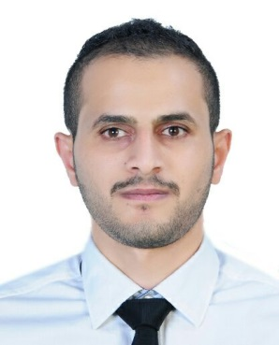CURRICULUM VITAE

AHMED ALASFOOR

ALASFOOR0093@GMAIL.COM | 38366402



|  |  |
| --- | --- |
| Personal Profile | Nationality: Bahraini **Date of Birth:** 2nd September 1993  **CPR Number:** 930909208  **Contact Number:** +973-38366402  **Email Address:**  ALASFOOR0093@GMAIL.COM |
|  |  |
| Career Objective/Summary | Committed to delivering quality results and exceeding expectations, Self motivated and able to work under pressure and time deadlines and Passion for delighting customers. |
|  |  |
| Work Experience | **2017 – present**  **Al Rashed group**  Customer sales associate 2015 - 2017Al Jawhara Motor Customer service 2011 – 2012 **Awal Gulf**  Manufacturer |
|  |  |
| Education | 2012 – 2015 UNIVERSITY OF PUNE Bachelor Commerce (B.COM)  Specialisation in Marketing Management 2008 – 2012 ALJABRIA SECONDARY SCHOOL Technical Application |
|  |  |
| Skills | **Skills:** MS-Office Applications  Ability to learn new skills  Ability to work under pressure  Hard worker |
| Interests | ReadingWritingInternet |
| Language skills | **Arabic**: Mother Tongue  **English**: Good understanding, writing, and speaking  **Hindi**: Understanding and speaking |